Ideation Phase Empathize & Discover

|  |  |
| --- | --- |
| Date | 16 November 2023 |
| Team ID | Team-593070 |
| Project Name | Project – Image Caption Generation |
| Maximum Marks | 4 Marks |

**EMPATHY MAP**

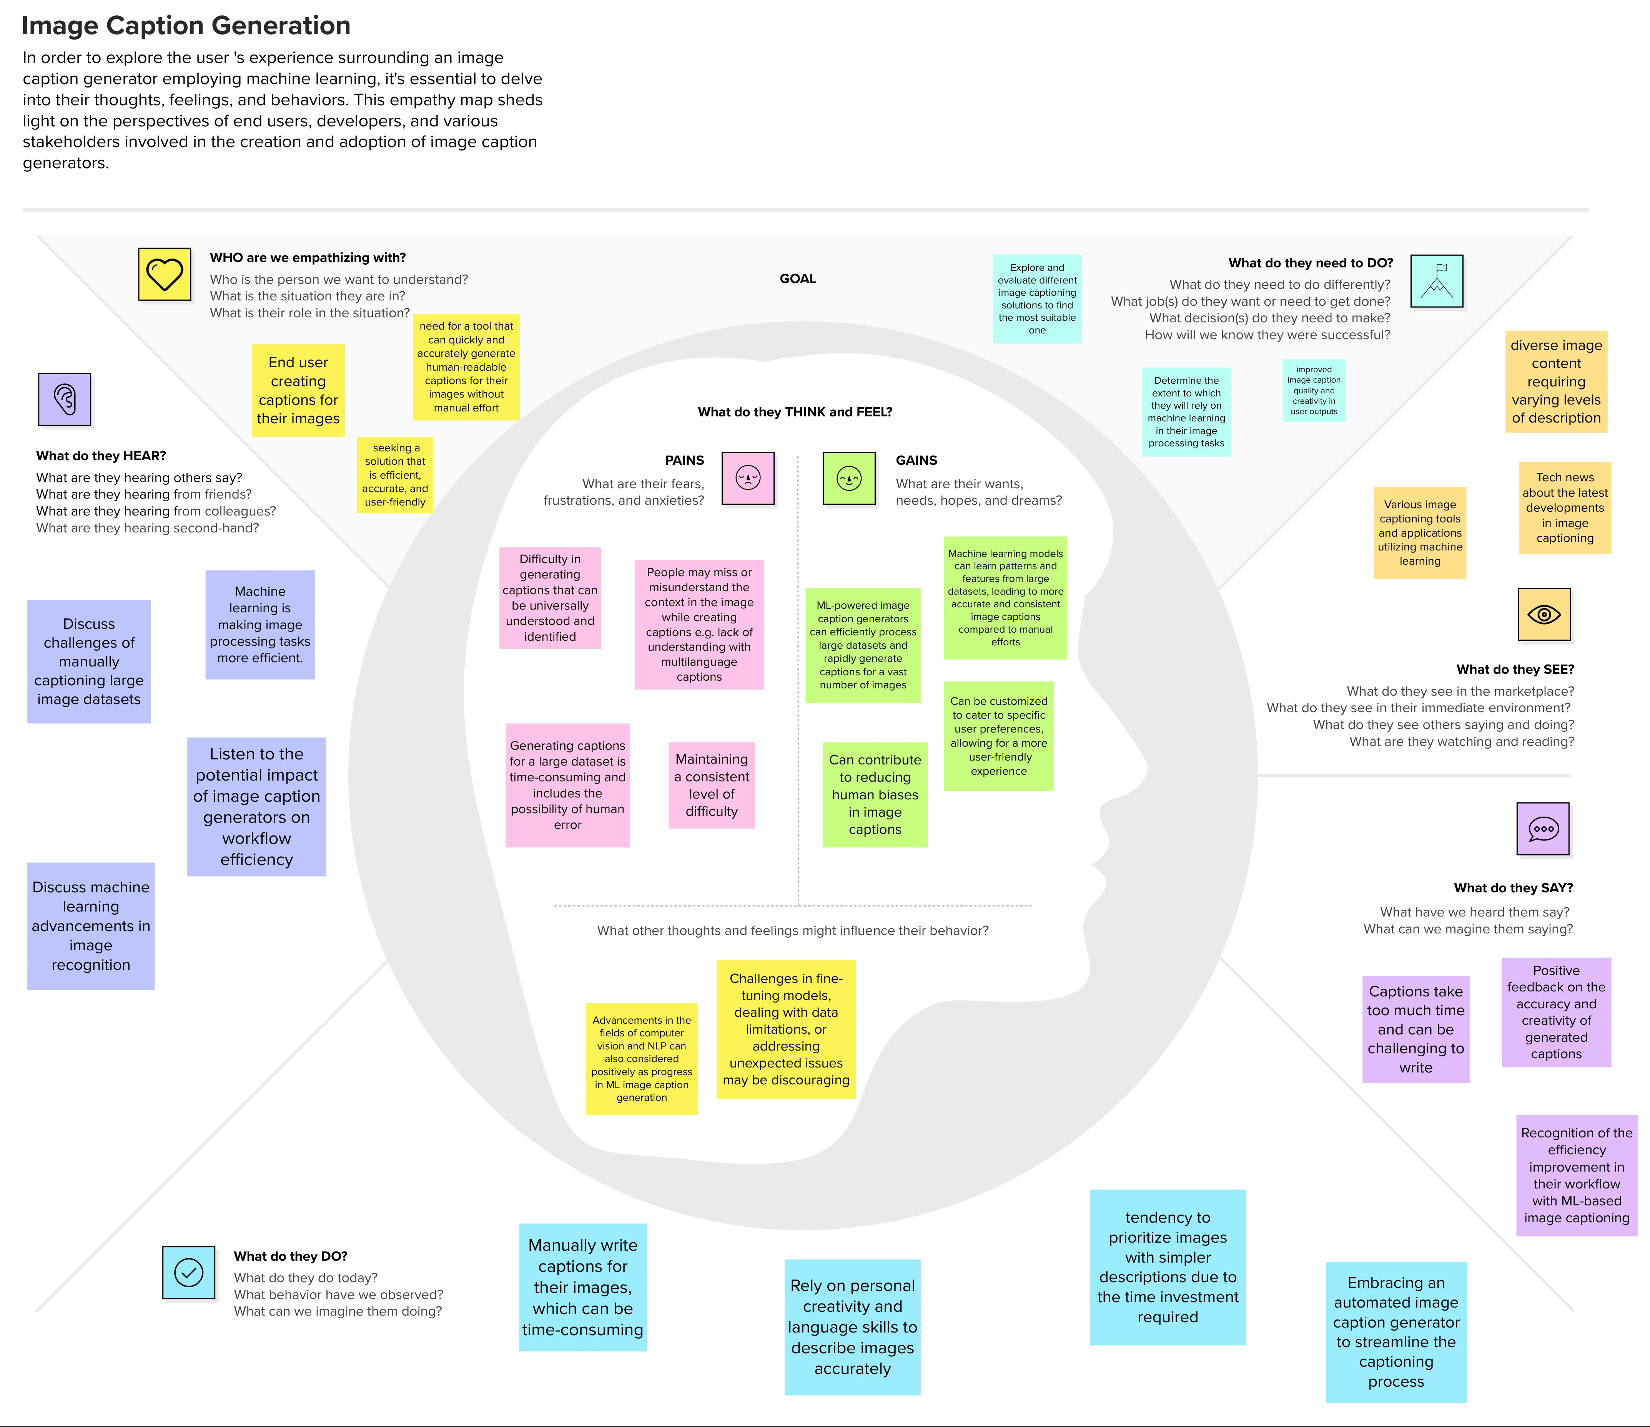

**BRAINSTORM MAP**